Minutes of the Committee Meeting 7th March 2016

Present: Nathan Scott Chairman
Andy Reid Secretary
Chris Green Treasurer
Dave Debnam Vice President
Paul Davies Men’s Captain
Lorraine Webb Ladies Captain
Andy Ward
Ashley Philpott
Thom Darby
Zena Ellis
Helen Morris

1 Chairman’s Comments
Quiet month for racing
Barrels training runs on Saturdays
No-one attended Donington National Championships due to injuries.
Event organiser to set up a club run.
Long winter!
I wish members the best for their training for the new season.

2 Apologies
Apologies were received from Miriam Linforth, who is unable to attend the meeting today.

3 Previous Minutes
The minutes for February were accepted.

4 Matters Arising
The venue for the awards evening is ready at Crawley Green Club. Cheryl McLaren will be providing the catering.
Coaches will not be supplied for the Manchester Marathon.
ACW events have agreed to organise our planned club race which will be in September.
A sub committee is needed from the club to guide the plans. Elaine Harries will be consulted for advice. The race will be a 5ml route with option to be 10mls using the course twice.

5 Secretary Report
Correspondence received:
Andy W. forwarded a video from AKA with advice on medications that would be considered doping.
Minutes of Bedsaaa meeting supplied
Agenda for 3CXC meeting received
Details of Swineshead 10ml
Triathalons in Bury St Edmunds and Mildenhall
Beds Track & Field course
Sharnbrook lost property still unclaimed
County Road Race certificates still to be distributed

6 Treasurer’s Report
CG reports

The Accounts.

Bank: £8,895
Cash in hand: £169.48p
The Garage rent has been paid which is £105/quarter.
The track sessions are costing £108

Beginners Course

To start promoting the course from today, for the 5th May start. The course will run until the 23rd July for 12 weeks. Helen has 50 forms available for joining the course.
Ashley will organise a facebook page for the course.

A Coaches Meeting will be organised this month

7 Running Report by Lorraine Webb & Paul Davies for November 2015
Running Report by Paul Davies & Lorraine Webb for February 2016
I’m pleased to say that little by little the evenings are staying lighter for longer. I for one cannot wait until we can spend our club nights running over the hills at the back of Inspire. In the meantime however, please bear in mind that it is still dark at 8pm so please wear suitable hi-viz or reflective clothing when out running.
February is also the month where some of us may begin to experience maranoia as the spring marathons get closer. We convince ourselves that every sneeze or cough is full blown flu and work colleagues/partners/friends who say they have a cold coming on are kept away at arm’s length and not spoken to again unless they can prove that they are in good health!
6th & 7th January
The month began with 15 Striders taking on the Luton parkrun. Liz Evans chose February as the month to get her first sub-30 5k when she crossed the finish line in 29:50. Well done Liz, great running.
Also on Saturday, David Brown ran the Cassiobury parkrun, Pete Breslin ran the Rushmere parkrun and Kate Neale travelled even further afield to run the Sherwood Pines parkrun in Mansfield.
Sunday saw 11 Striders running the “flat as a pancake” Watford Half. Joking aside, those Striders who ran it commented on how hilly it was but that did not stop two of them achieving PB’s. First home was Thom Darby in 1:40:59. Thom was closely followed by Andy Smith (1:42:15), Simon Norris (1:45:13), Daniel Mann (1:45:28 PB), Nick Crane (1:51:39 PB), Andy Durrant (1:51:46), Tom Willis (1:52:03), Willie Ellingham (1:58:15), Martin Smith (2:06:07), Finbar Willis (2:11:27) and Valerie Dawson (2:17:14). Well done all, especially Nick & Dan who managed PB’s on a tough course.

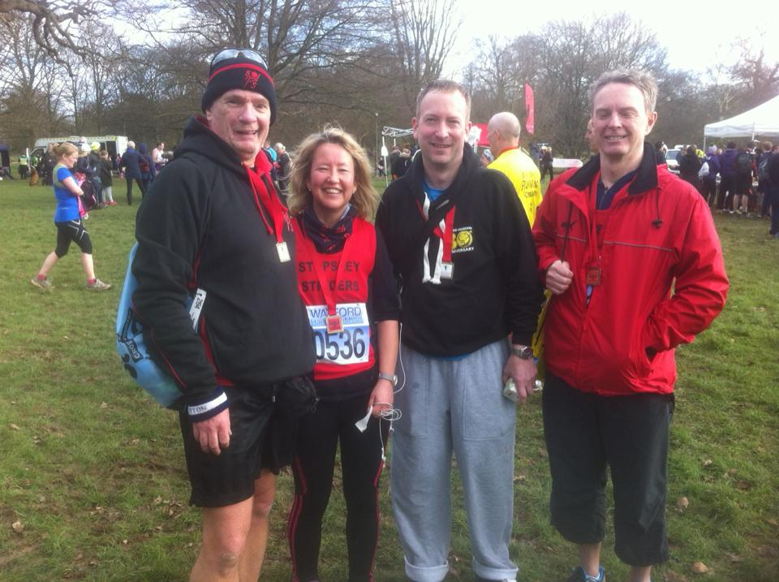

Sunday also saw Miriam Tedder partner up with Ravenshead Runners in Nottinghamshire to take on a muddy team trail half marathon.
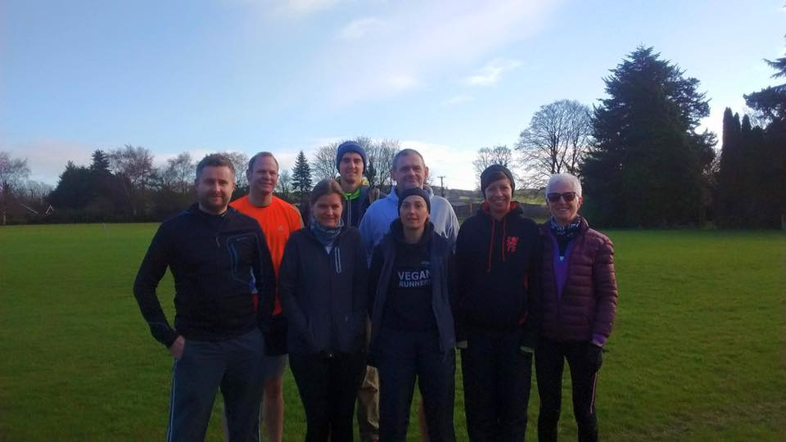
13th & 14th February
20 Striders ran the Luton parkrun on the Saturday. New Strider Rob Barnes ran his first ever parkrun and finished 2nd overall in a time of 17:53. Impressive stuff Rob! Liz Evans gained another parkrun PB, her second in as many weeks when she finished in 29:46. Sub 29 for March Liz? Donna Wiggett also bagged herself a PB when she crossed the line in 32:11.
Also on the Saturday, Graham Busch ran the Bedford parkrun.
On Valentines Day, 7 Striders ran the Love Welwyn GC 10K. Both Vanessa Thompson and Donna Wiggett were feeling the love as they crossed the finish line as both gained 10K PBs. Well done Ladies! Overall, Pat Blessing was first Strider home in 42:49 and 2nd Vet 50. Pat was followed by Vanessa Thompson (50:20 PB), Kieran Fitzpatrick (50:36), Willie Ellingham (51:20), Kim Caddy (54:38), Finbar Willis (54:57) and Donna Wiggett (1:08:18 PB).
Valentines Day also saw Andy Smith complete the St Valentines 30K in Stamford, Lincolnshire in a time of 2:32:11.
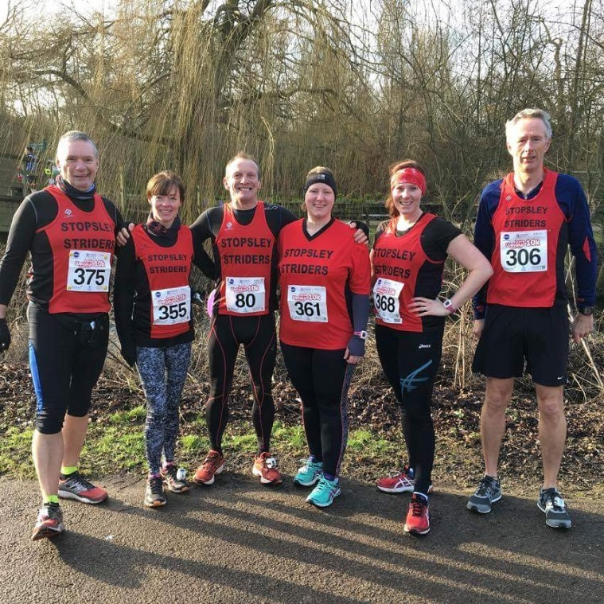
20th & 21st February
16 Striders took on the Luton parkrun on the Saturday morning with both Dani Gibson and Hannah Fothergill bagging themselves PB’s. 6 PB’s in a row for Hannah – how long will her PB streak continue? 3 Striders travelled up the A6 to run the Bedford parkrun and Gerri Tate travelled further afield and ran the York parkrun.
Sunday wouldn’t be the same without Andy Smith doing a race somewhere. Andy completed the Wokingham Half Marathon in a time of 1:41:54. Well done Andy and how about having a Sunday off?
27th & 28th February
10 Striders turned out for the Luton parkrun with Liz Evans gaining another PB. Liz crossed the finish line in 29:34. I think sub 29 during March is looking very likely now Liz!
Miriam Tedder travelled to Milton Keynes to run their parkrun and Gerri Tate once again ran the York parkrun. Whilst in Ireland, Pete Breslin took on the Letterkenny parkrun.
Sunday (now known as Andy Smith Race Day) saw Andy Smith run the Kingston Half Marathon and he finished in a time of 1:32:54. Sunday also saw Rob Barnes complete the St Peters Way 45 Mile Ultra. Not only did Rob finish in an impressive 6:21:35, he came 3rd overall. Excellent running Rob!
March 2016 promises to be a challenging month with many Striders running the MK20 and Finchley 20 races. For some this will be the first time that they have tackled this distance. Remember, the club has a fantastic number of experienced runners and coaches so please do speak to them if you have any questions or concerns as they will be able to share their experiences and advice with you.
March is also that time of year when physio’s become ridiculously busy as the spring marathons get ever closer! Whatever your goals, be it your first 20 miler or your first 5k, run well, stay safe and mostly importantly enjoy running.

8 Strider of the Month
Strider of the Month was awarded to:
- Liz Evans

9 Suggestions Box

Would the committee consider a non member, Amanda Rankin’s husband, for an award for his photographs of members at races. Not agreed

Could photo’s of members achieving P.B.’s be put on the website. To be considered.

Nathan The Inspire room is costing £35/night for meetings. Shall we look at moving to the Working Mens Club for the committee meetings?

Cont.
Andy W. Suggested taking part in some 2 person relays. The information will be passed to Dave D. for the website.
AW would like to introduce organised stretching after the runs back in the meeting room. The room is booked until 9.15 for us.

Dave D. Suggested a form to update members info re house moves and personal changes of details. We will use a renewal form for notifying changes for the April membership renewals.

Andy R. None

Ashley P. Suggests Cram tags or similar for members to cary on club nights, or cards with info for emergencys.

Nathan S. Speed training group should have First Aid kit and card info on group members.

Thom. D. Could we reduce costs for new members by paying the affiliation costs for the 1st year? Not agreed.

Zena Why doesn’t the person who writes the citation read out the citation at the awards evening?

Lorraine E None

Paul None

Awards Evening

Evening will begin at 7.30 until 8.30. Then the food will be available from 8.30pm, with the presentation of the awards following.

Next meeting to be held on 04/04/16

11 AOB

Next committee meeting on 04/04/16

